**1.Created IAM user “Vikram” and assigned certain policies to user**

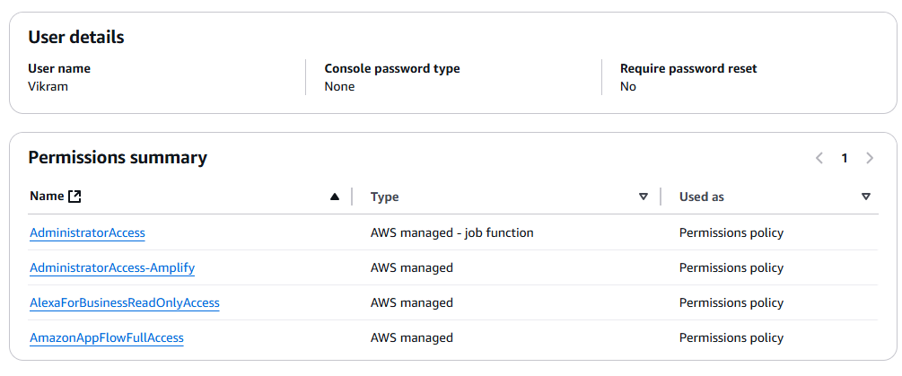

2. Assign Role to user Vikram

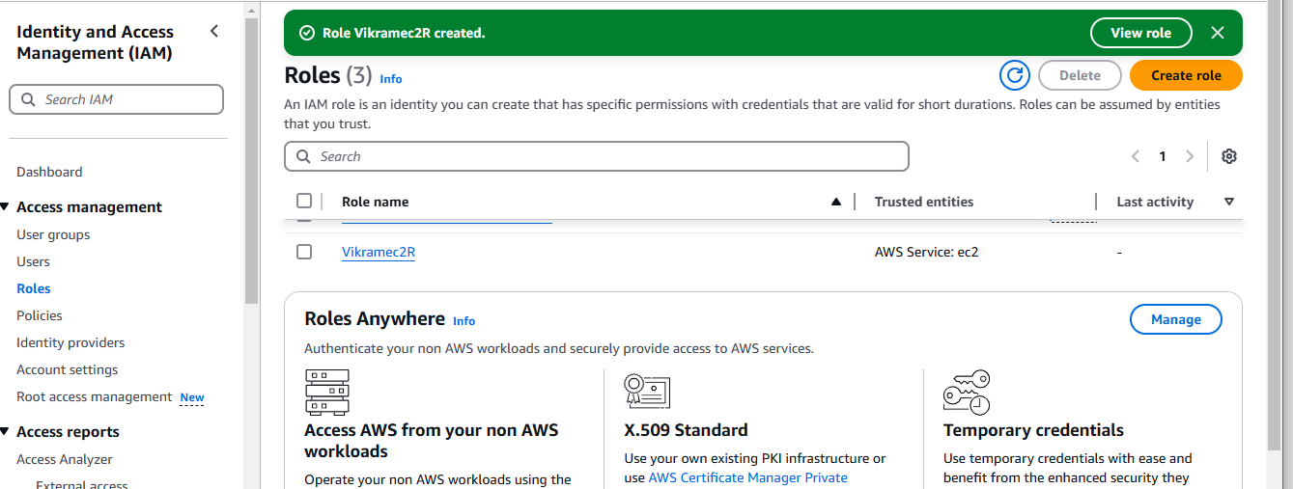

3.Created EC2 instance

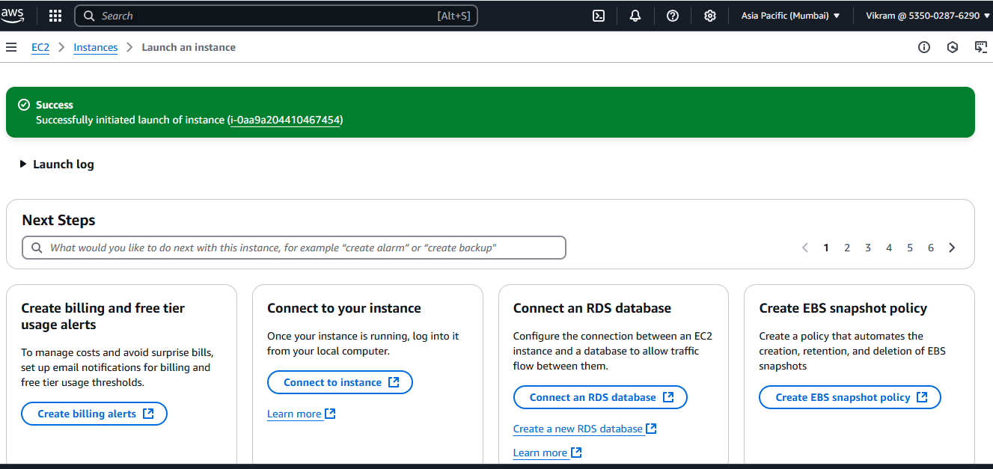

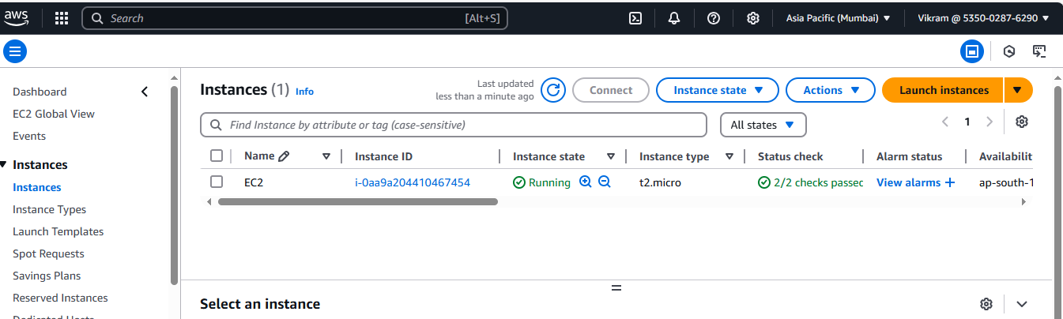

4.Created User via CLI

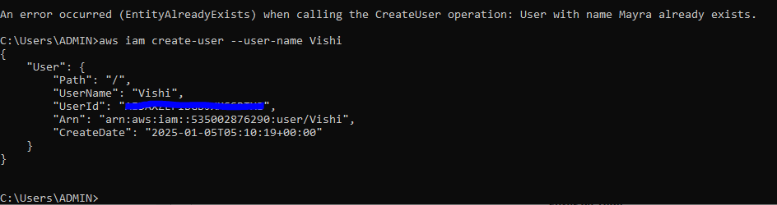

5.Created group via CLI

